Bisection Method

Or

Bolzano Method

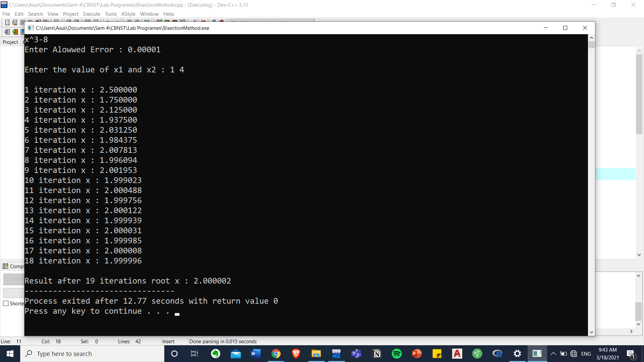

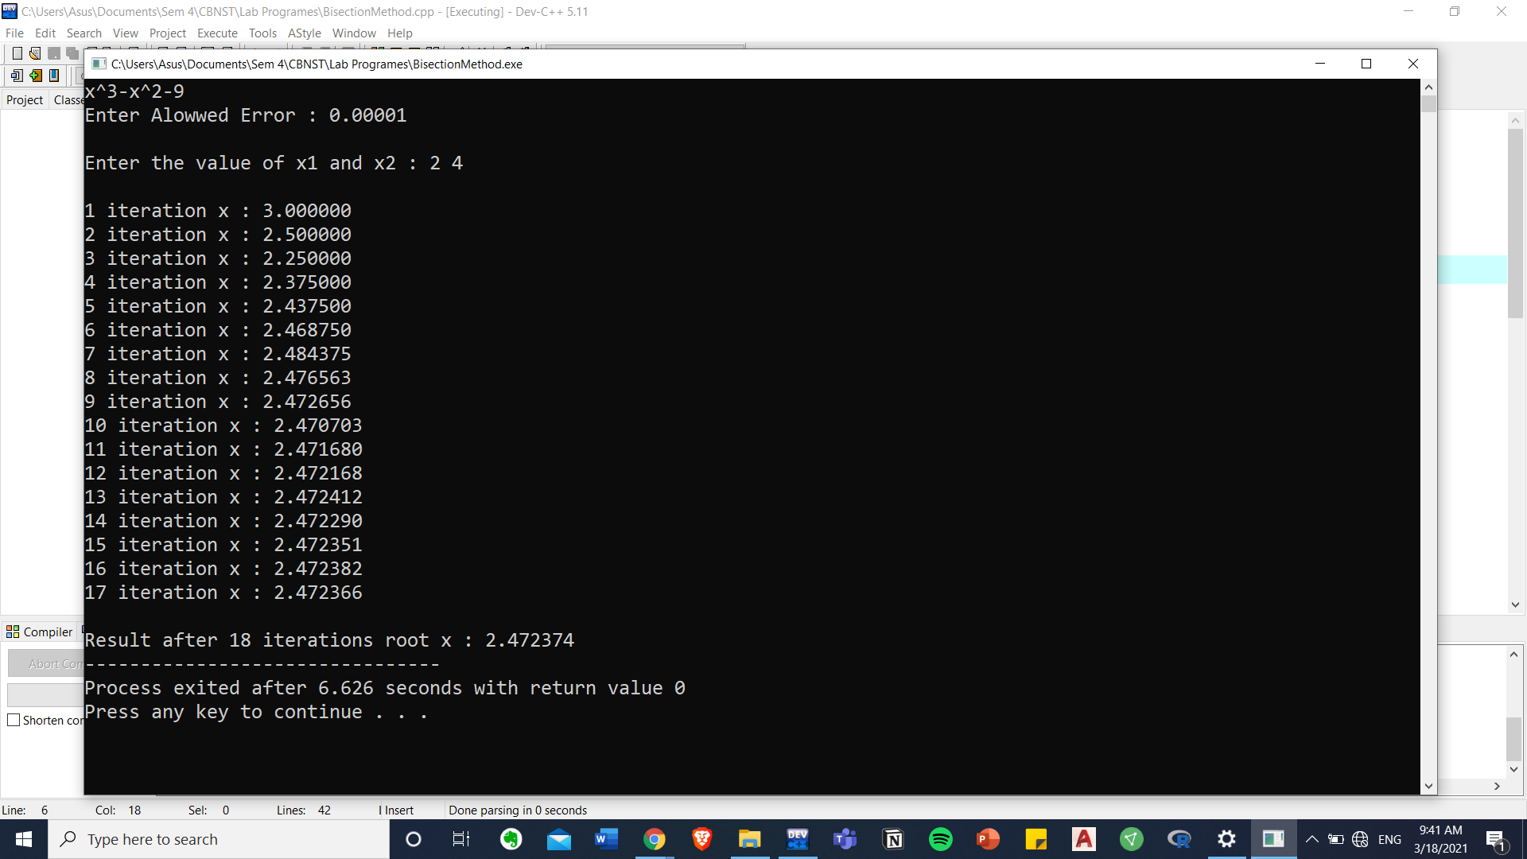

Iterative Method

Or

Successive Approximation Method

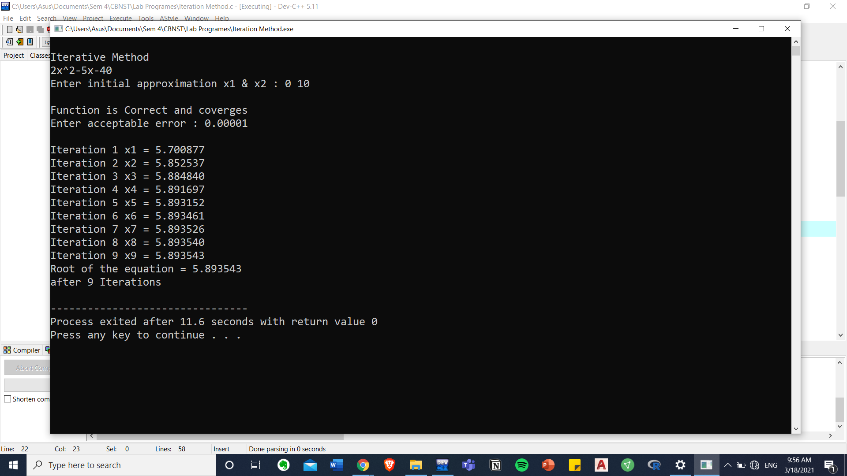

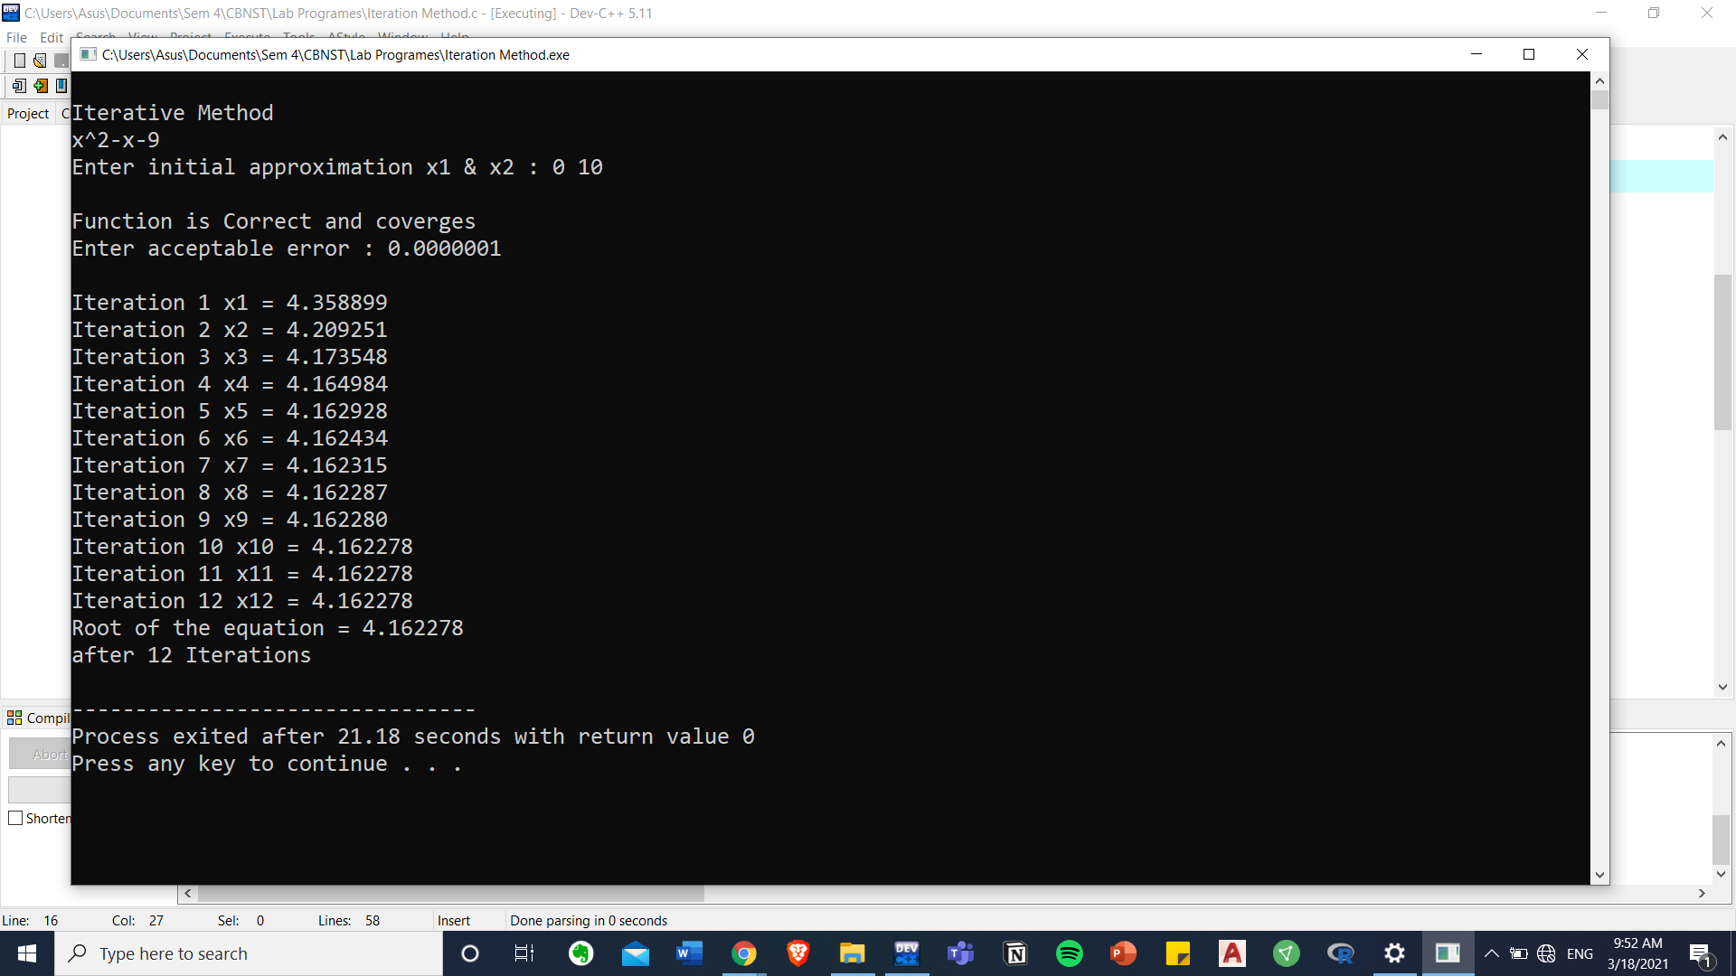

Regula Falsi Method

Or

Method of False Position

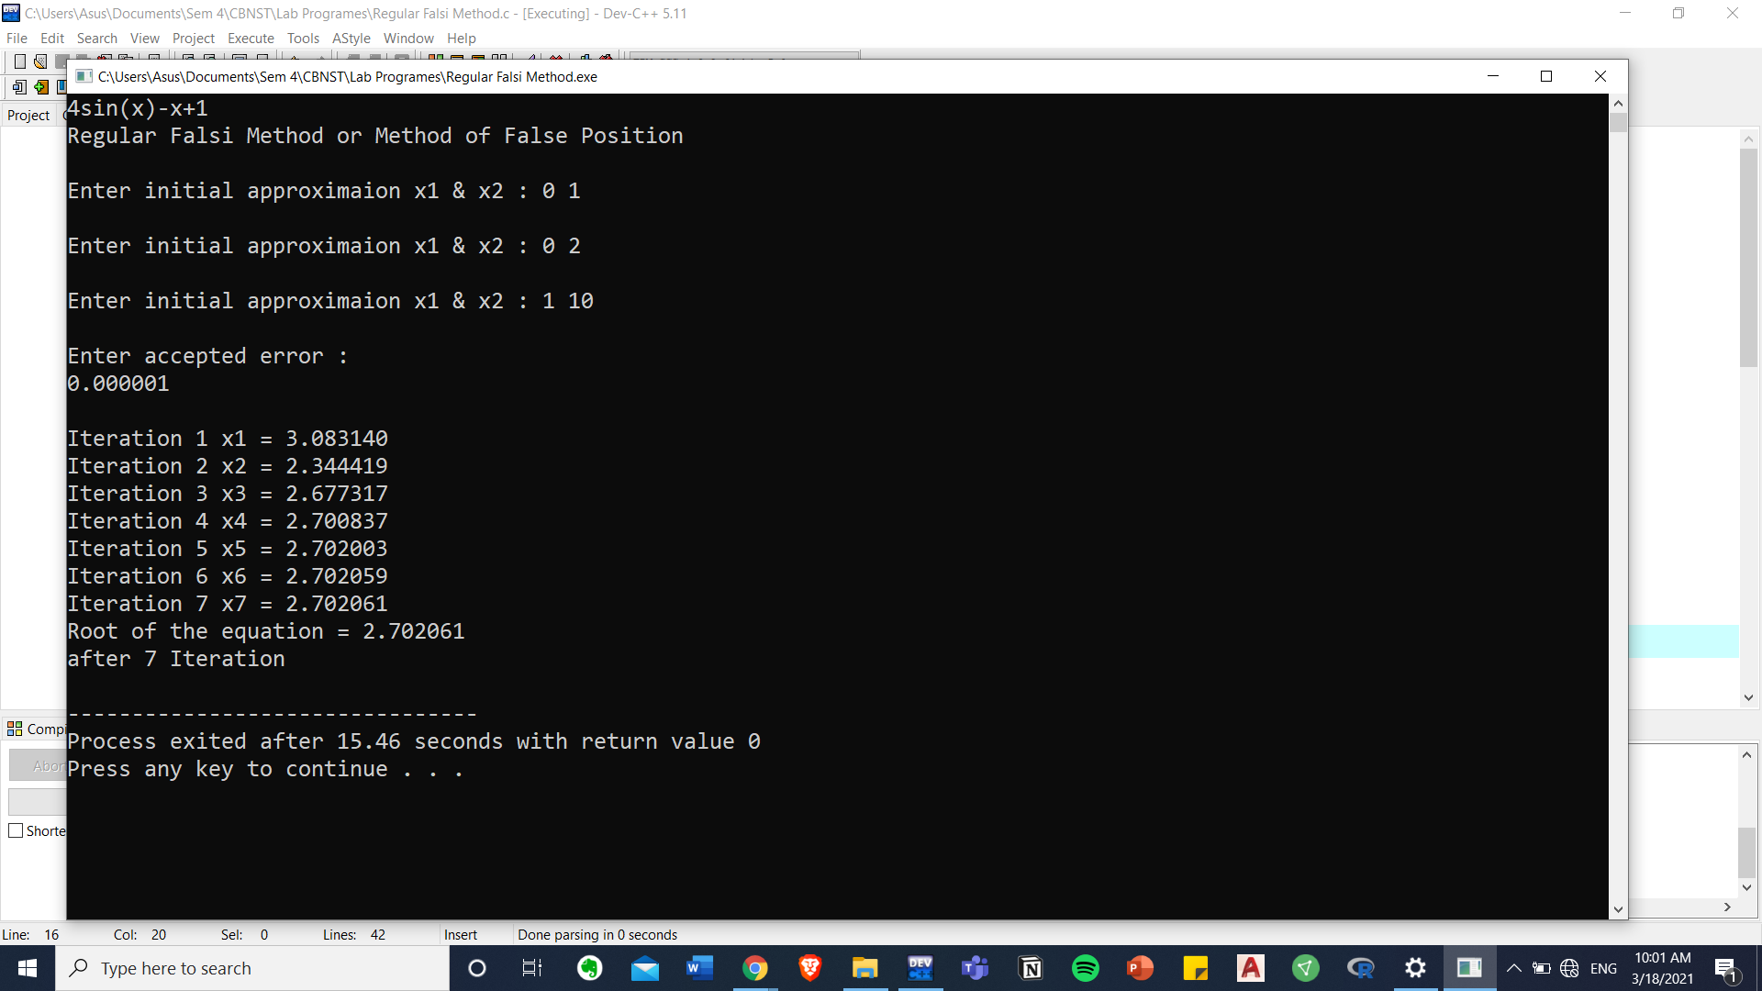

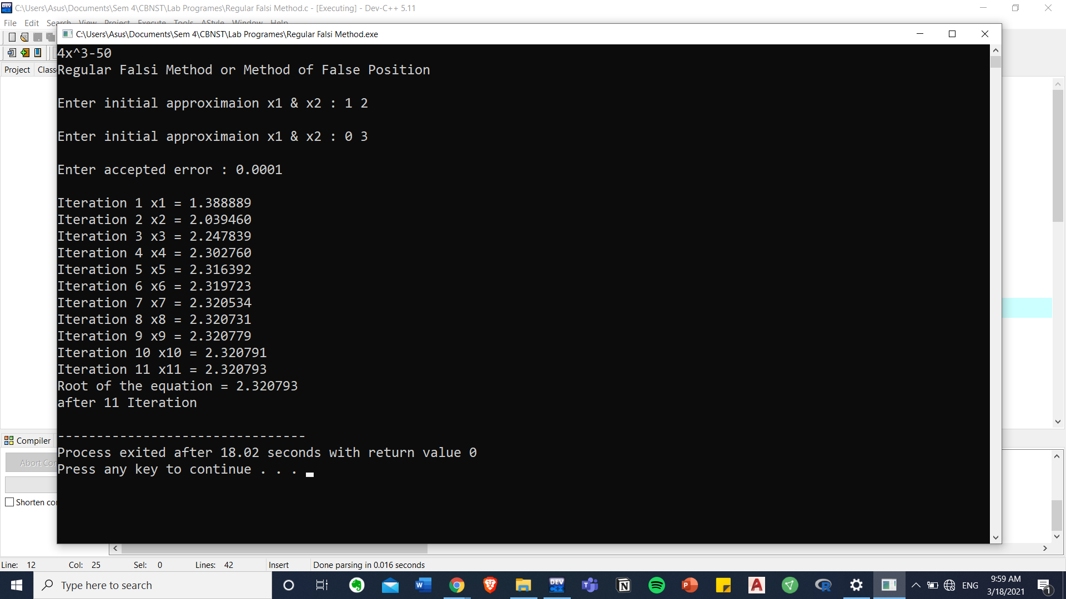

Newton Raphson Method

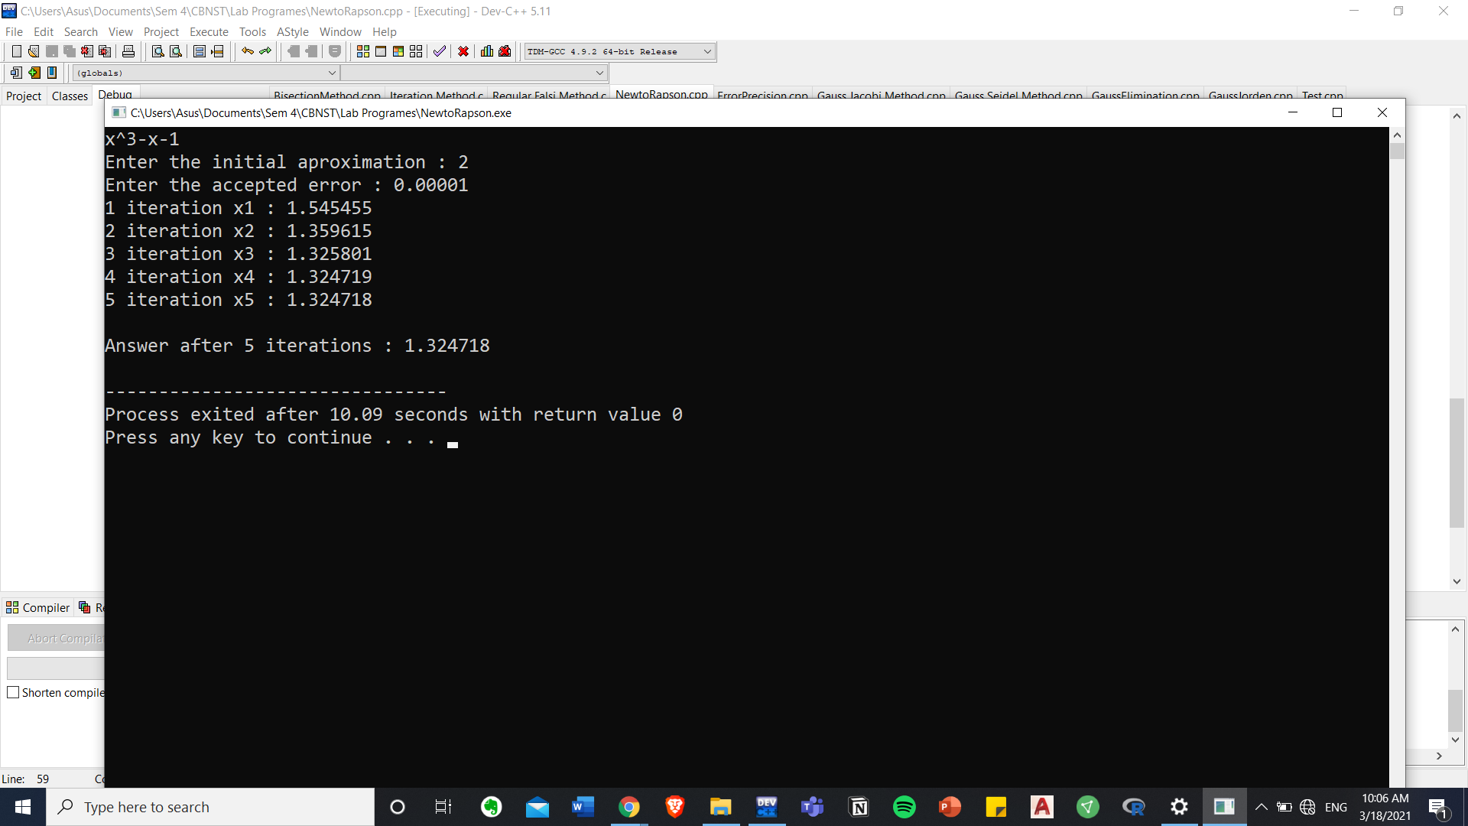

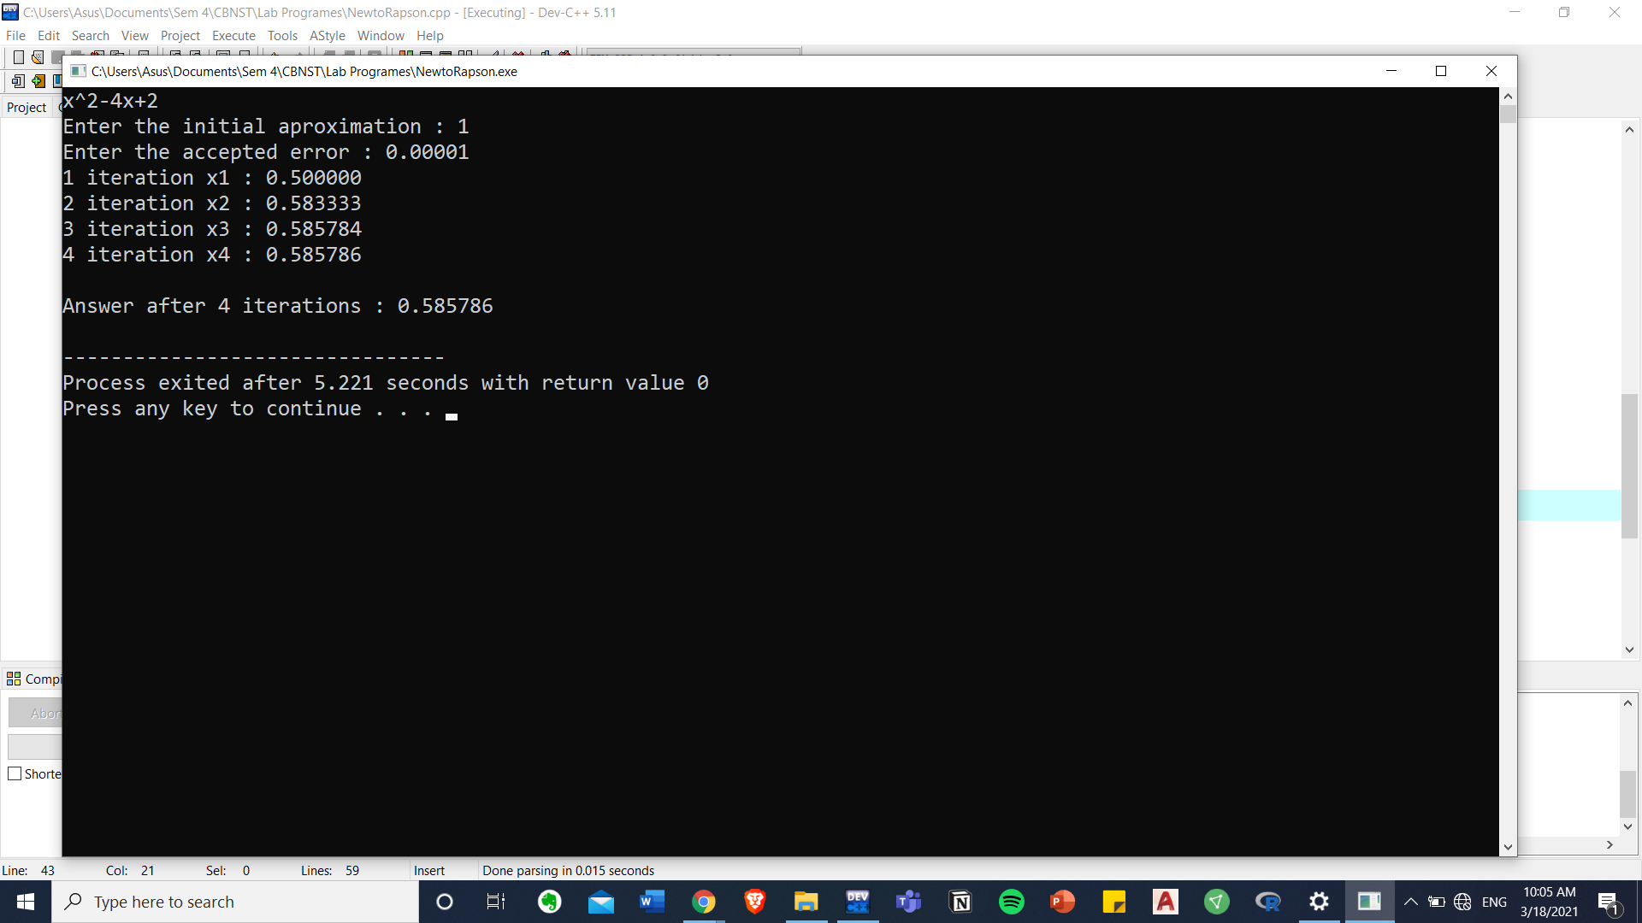

Error

Absolute Error

Relative Error

Percentage Error

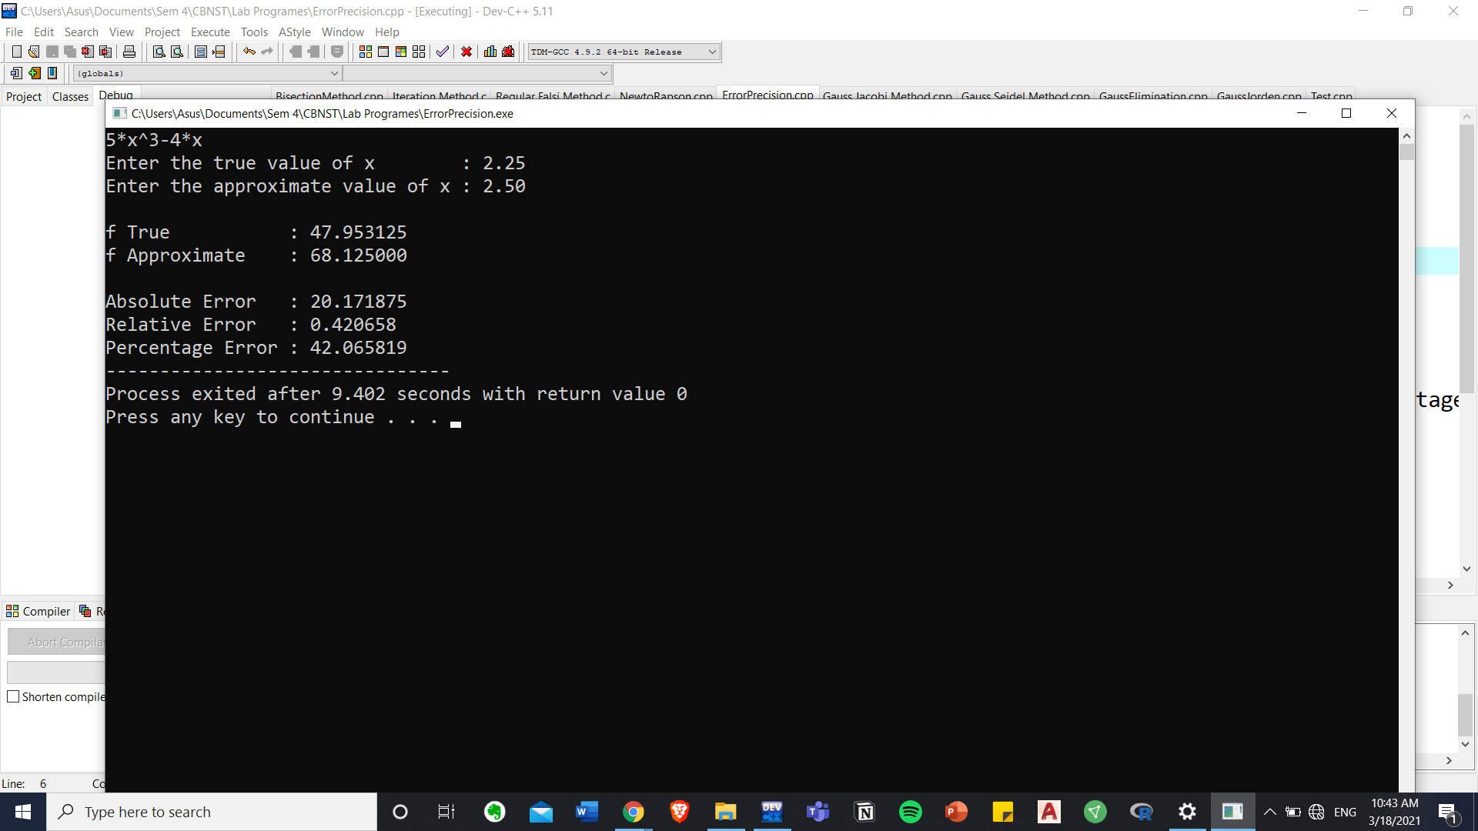

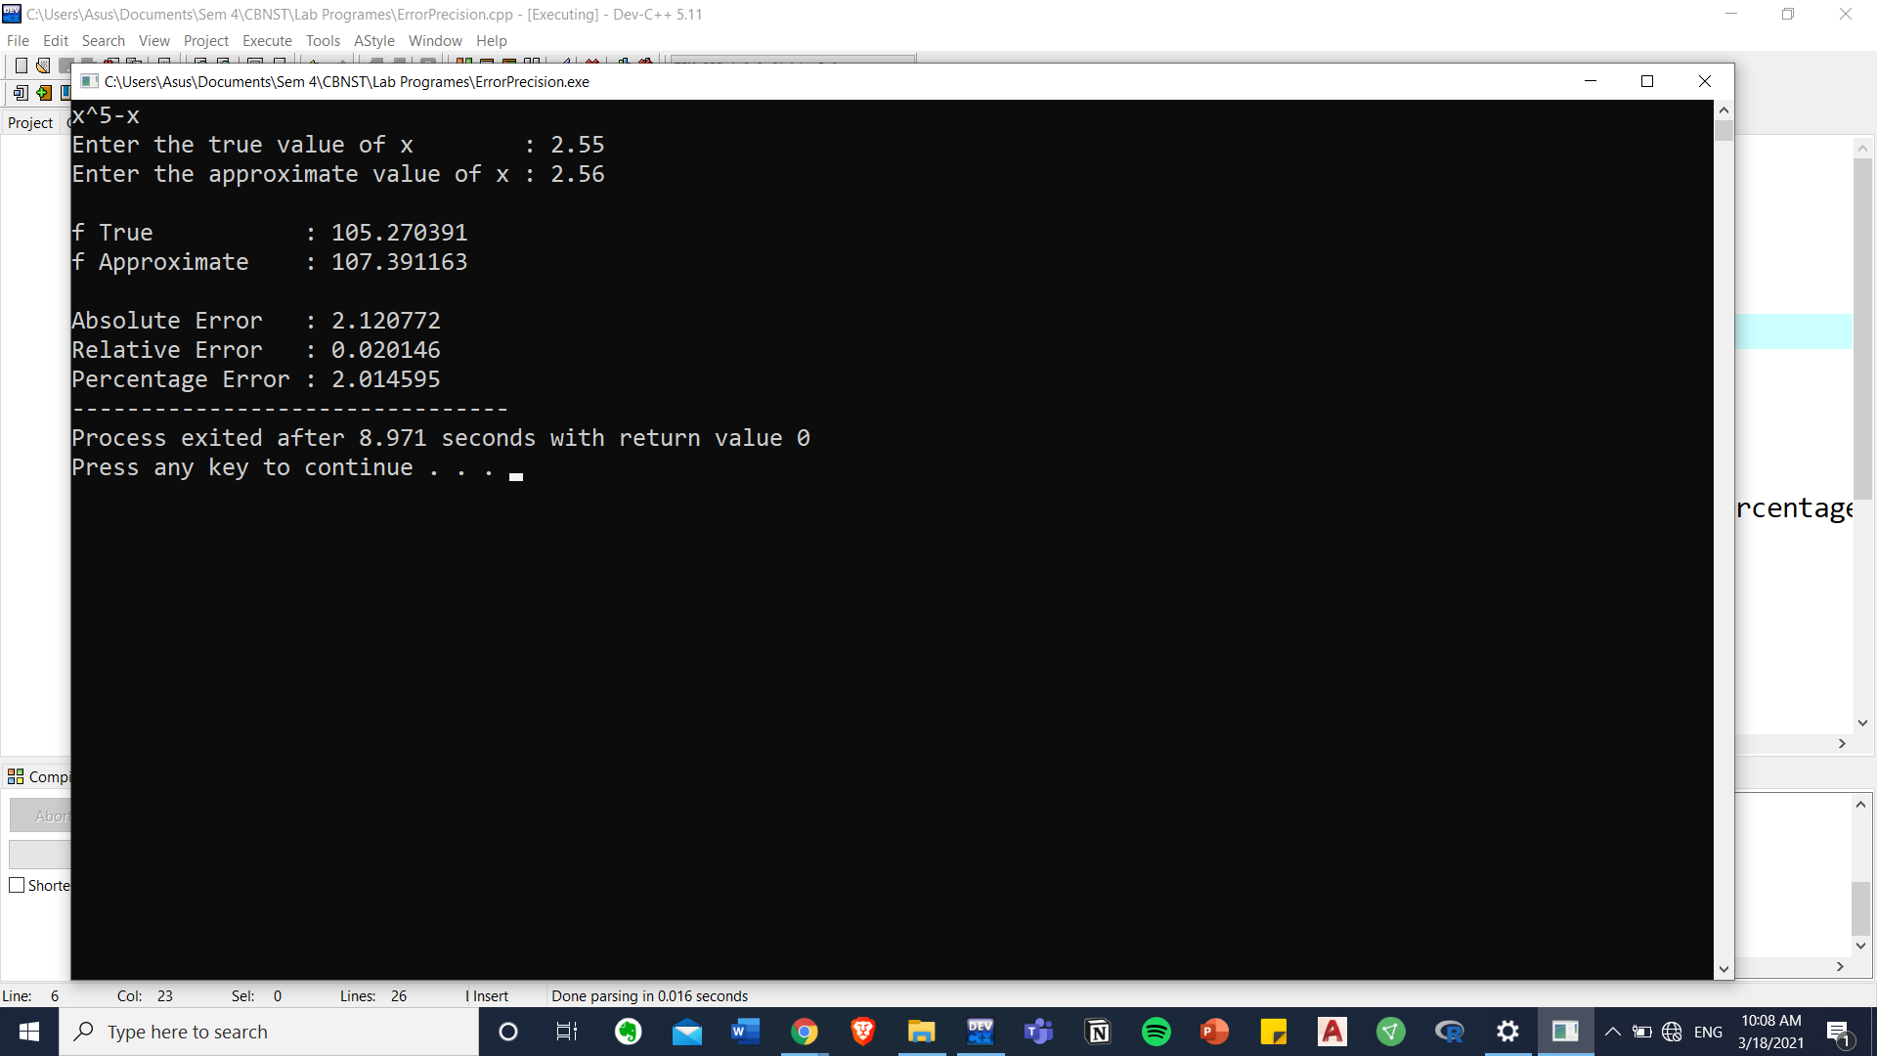

Gauss Jacobi

Iterative Method

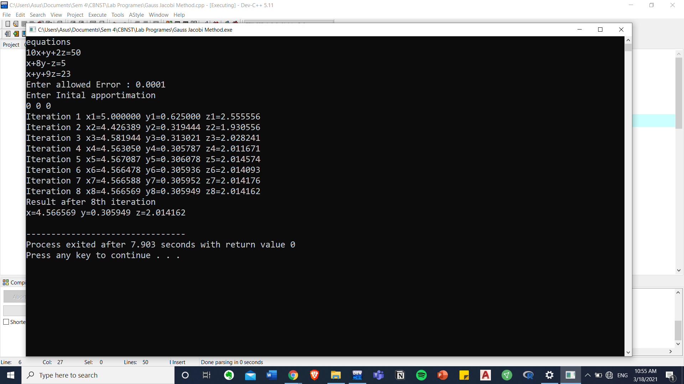

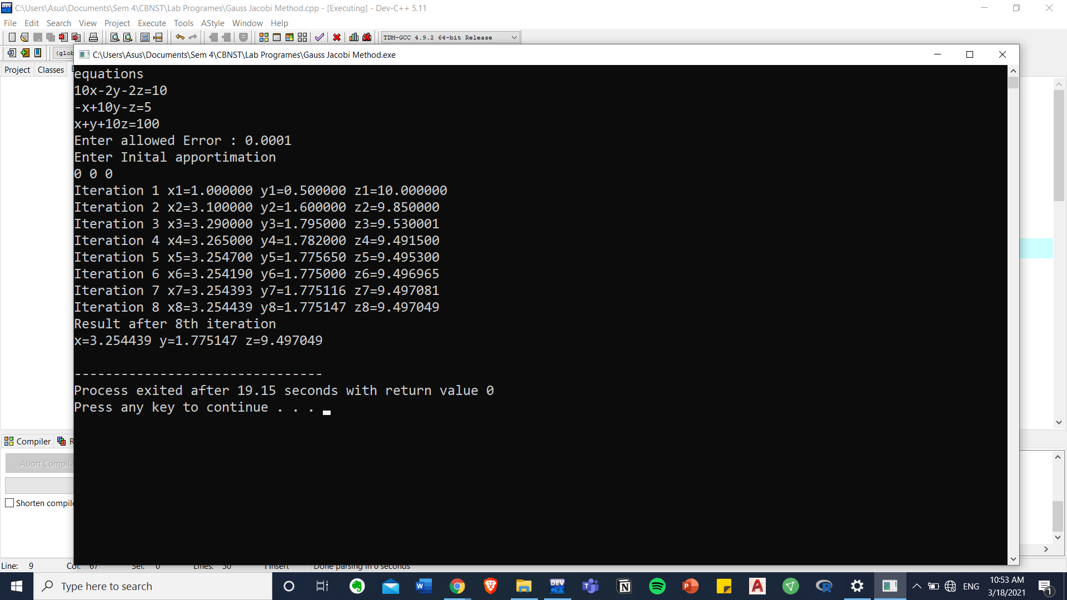

Gauss Seidel

Iterative Method

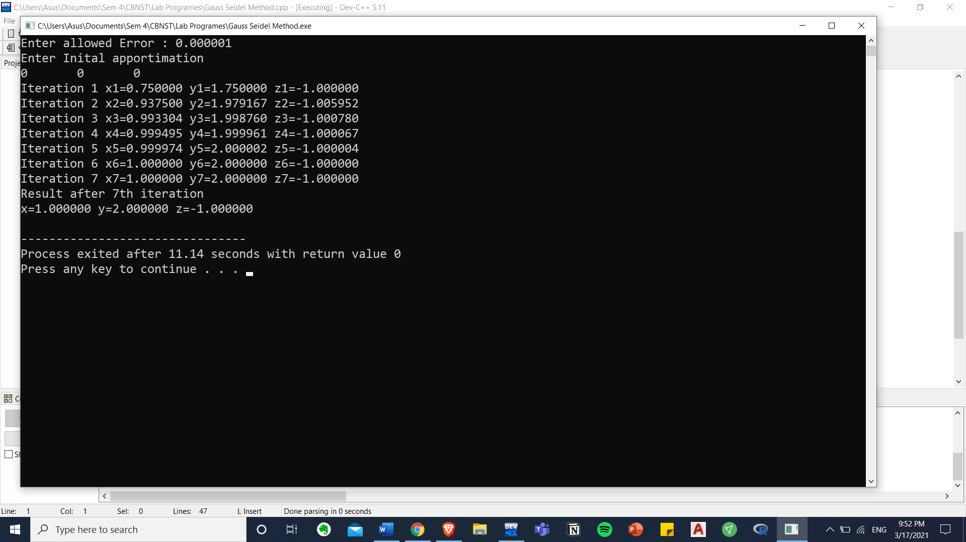

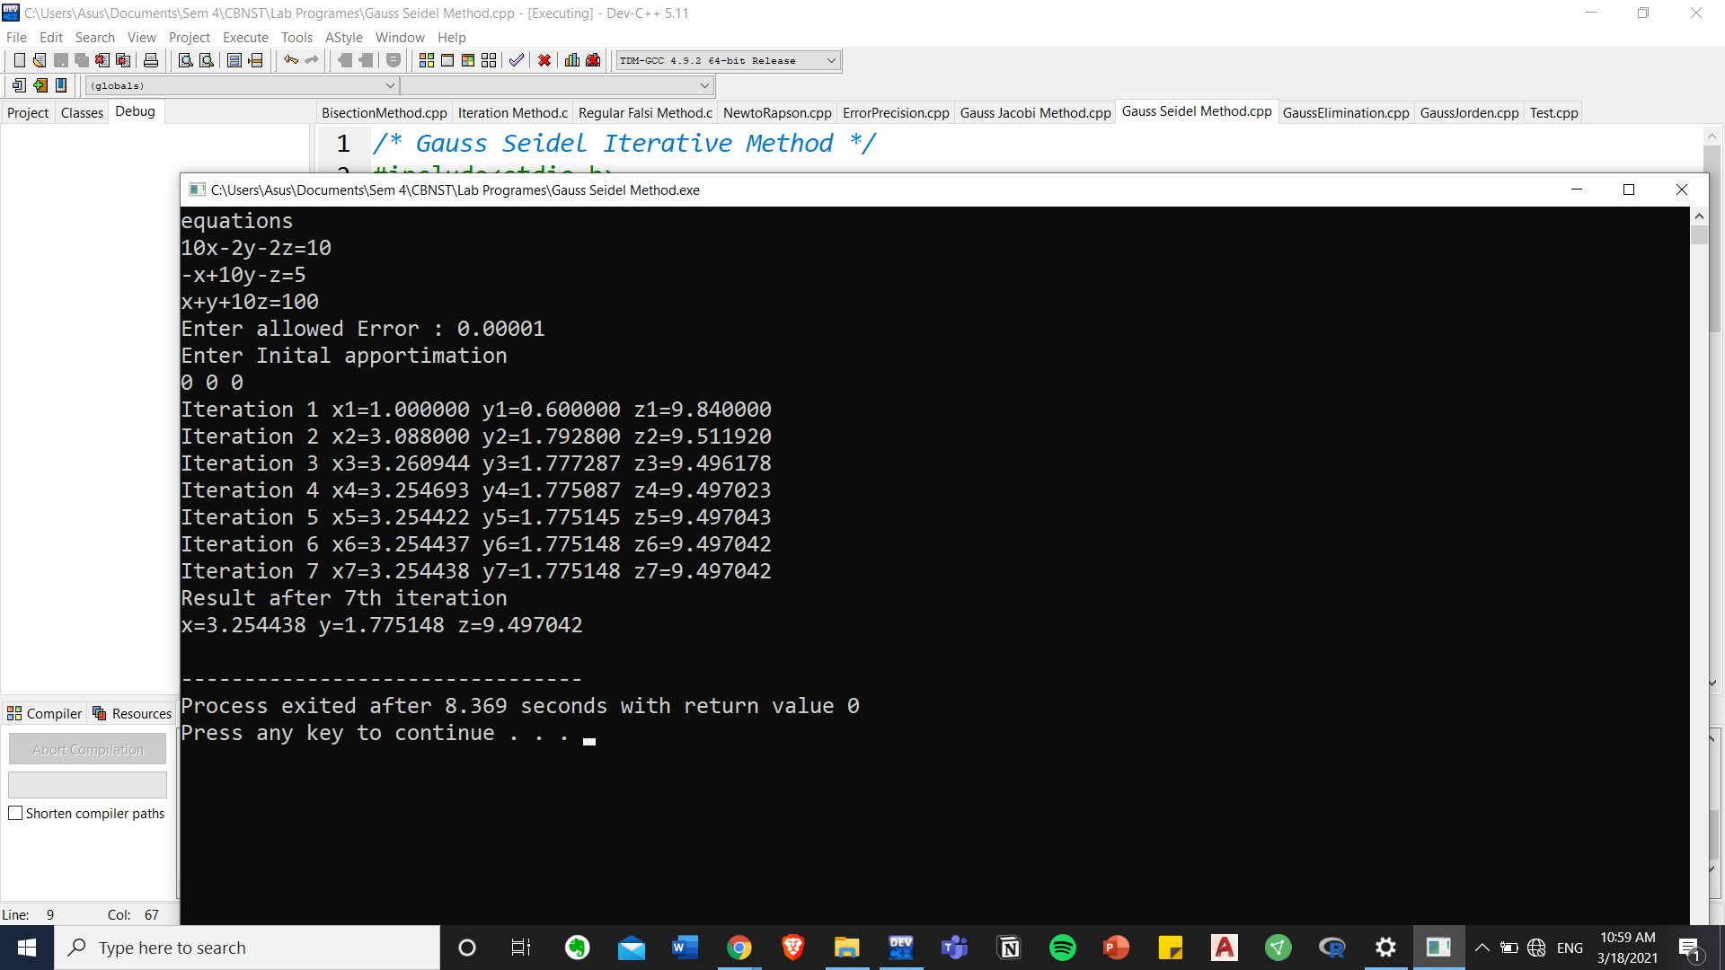

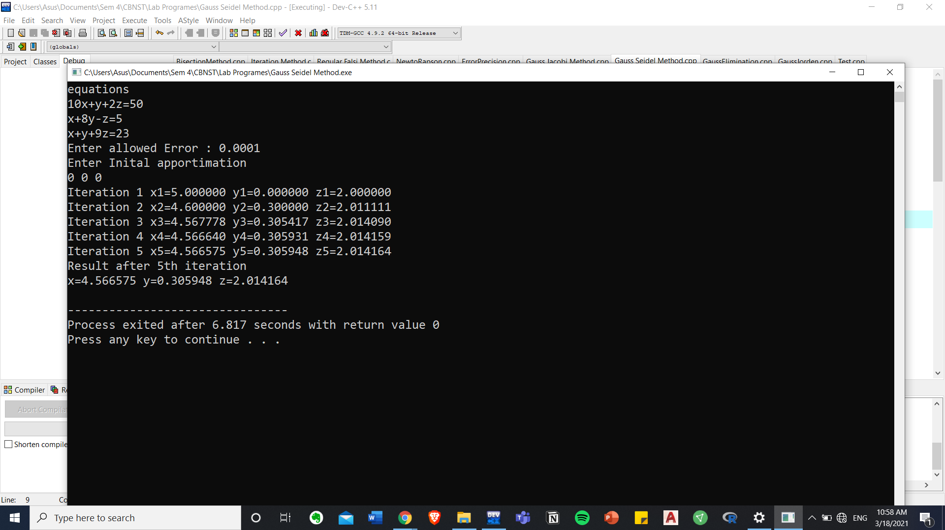

Gauss Elimination Method

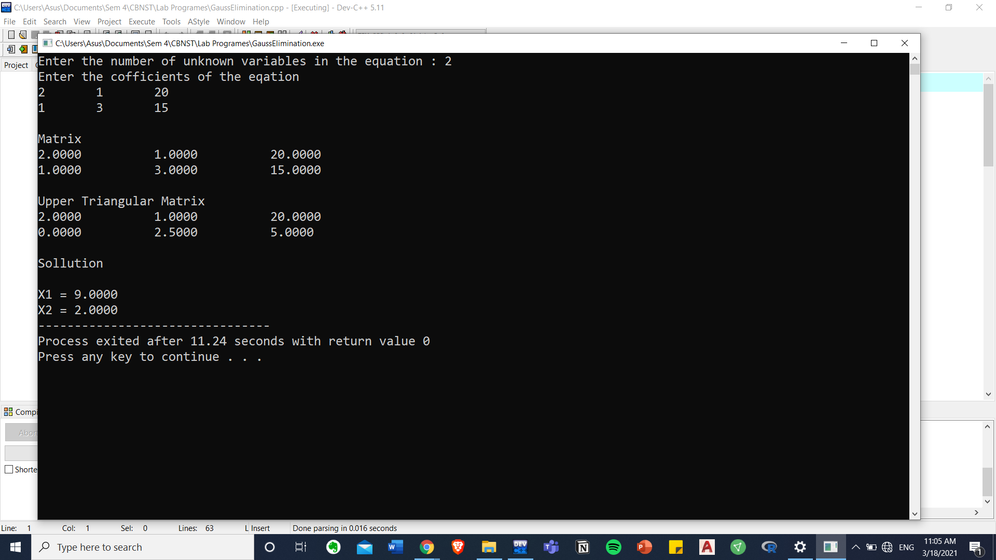

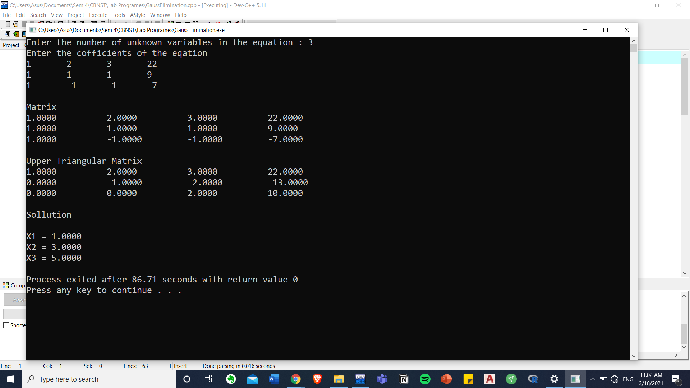

Gauss Jordan Method

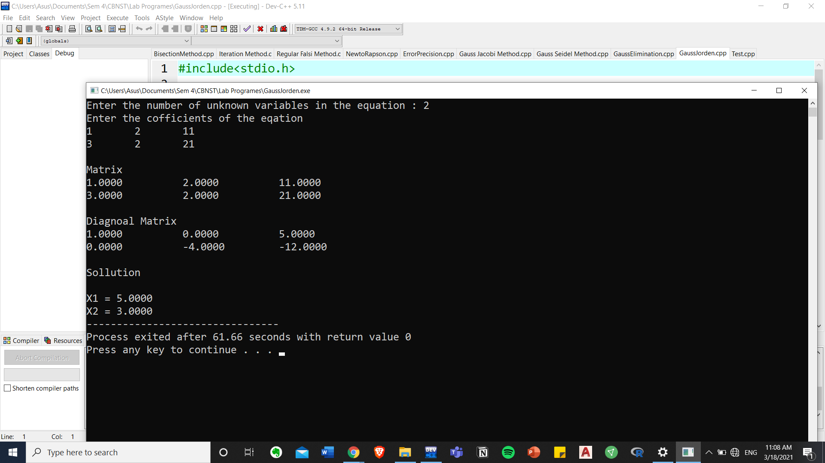

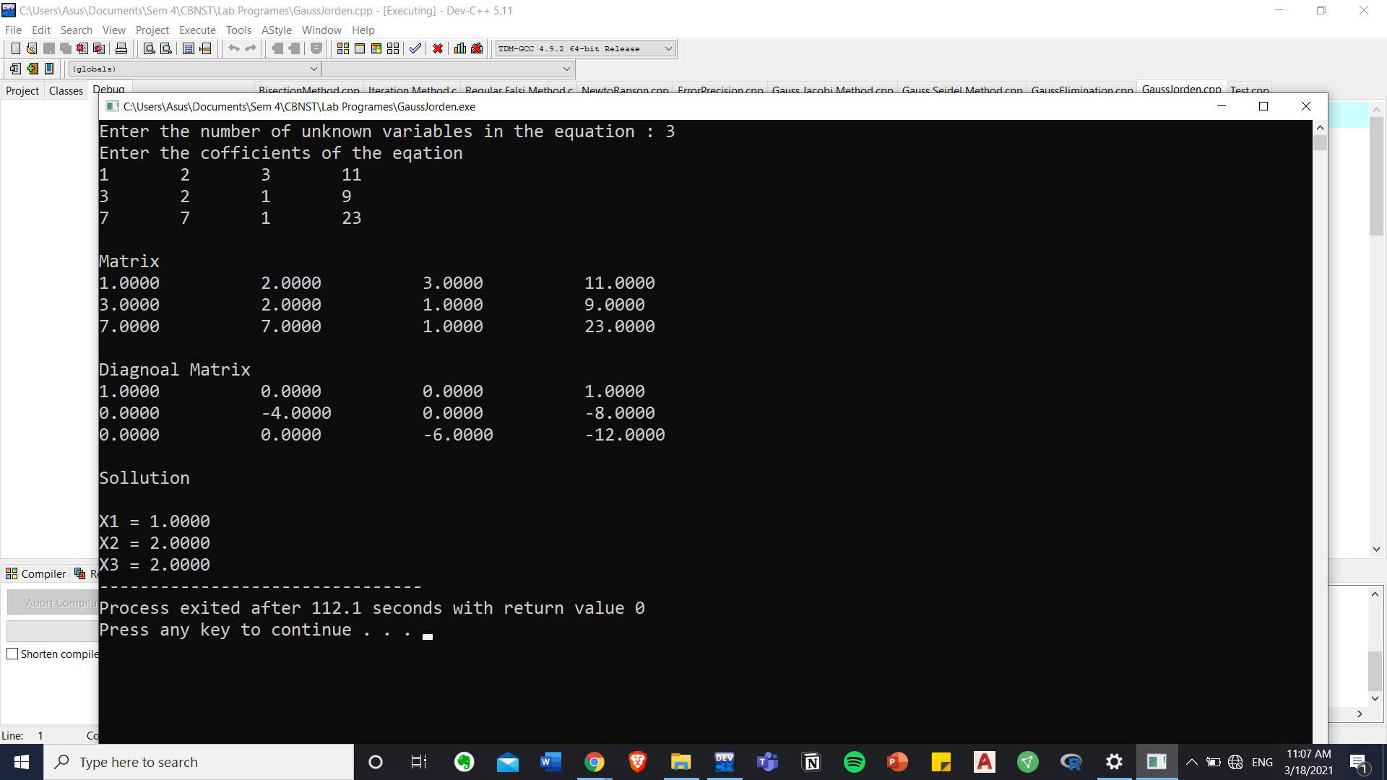

Secant Method

